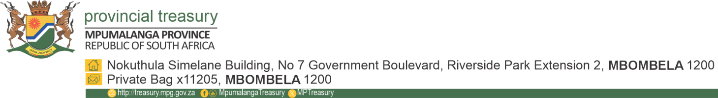
MEDIA ADVISORY
Date: 25 May 2026
To: Editors / Producers / Journalists
FOR IMMEDIATE RELEASE
Mpumalanga Provincial Treasury to host SMME workshop in Dr JS Moroka Local Municipality
The Mpumalanga Provincial Treasury will host a one-day workshop to empower Small, Micro, and Medium Enterprises (MSMEs) within the Dr JS Moroka Local Municipality.
The workshop is part of the department’s ongoing efforts to support local businesses by equipping entrepreneurs and suppliers with the knowledge and tools needed to participate effectively in government procurement processes and broader digital transformation initiatives.
Attendees will be capacitated on a range of key topics, including government Supply Chain Management opportunities, bid administration, completion of Standard Bidding Documents (SBD) forms, Central Supplier Database (CSD) enhancements and updates, invoice tracking, as well as the newly conceptualised Mpumalanga Provincial Government e-Recruitment system.
Event details:
Date: Wednesday, 27 May 2026
Time: 09h00
Venue: Libangeni Community Hall, Dr JS Moroka Local Municipality
Members of the media are invited to attend and cover the workshop.
For more information and media confirmations, please contact Ms Kulani Mavunda at 079 074 2391 or k.mavunda@mpg.gov.za.
The End



